# \*\*\*\*\*\*\*\*\*\*\*\*\*\*\*\*\*\*\*\*\*\*\*\*\*\*\*\*\*\*\*\*\*\*\*\*\*\*\*\*\*\*\*\*\*\*\*\*\*\*\*\*\*\*\*\*\*\*\*\*\*\*\*\*\*\*\*\*\*

|  |  |  |
| --- | --- | --- |
| *S I G N A L S* | | |
| RClogo_col_wordtemp |  | Monthly Newsletter of the |
| *Amateur Radio Club* | |

Volume 38 Issue 04 **Web Site** [**http://www.w5rok.us**](http://www.w5rok.us)**January 2017**

**\*\*\*\*\*\*\*\*\*\*\*\*\*\*\*\*\*\*\*\*\*\*\*\*\*\*\*\*\*\*\*\*\*\*\*\*\*\*\*\*\*\*\*\*\*\*\*\*\*\*\*\*\*\*\*\*\*\*\*\*\*\*\*\*\*\*\*\*\***

|  |
| --- |
| **RCARC**  **Membership Meeting**  **Tuesday 24 January 2017**  **1700 Social 1730 Meeting**  **1800 Program**  **Methodist Richardson Medical Center**  **At Bush/Renner/Shiloh Intersection**  ***Conference Room A in Hospital Building***  ***Subject:***  ***To Be Announced*** |

**Local Club News**

**Meeting Notice**

The program for this month’s meeting was still being planned at the time of publication. So come to the meeting on Tuesday, 24 January and expect to be surprised.

**RCARC Community Service Activities**

***Siren Testing*** Dennis Cobb WA8ZBT, John McFadden K5TIP, Frank Krizan K5HS and Jim Skinner WB0UNI participate in the Richardson emergency siren testing. The testing on 4 January 2017 revealed performance problems with numerous sirens—it appears that no repairs were made since the problems were reported last month. The siren testing is performed at 12:00 on the first Wednesday of each month. The sirens are monitored by amateur radio operators and reports made using the Richardson Wireless Klub (RWK) repeater at 147.120 MHz. Siren testing occasionally uses the University of Texas at Dallas (UTD) repeater at 145.430 MHz, which is designated as the backup repeater.

***Crime Watch Patrol*** Jim SkinnerWB0UNI participated in Richardson Duck Creek Crime Watch Patrol (CWP). CWP members, after successful completion of Richardson Police Department Training, patrol their neighborhoods and report all suspicious activities to the Police Department.

**2016 Christmas Party**

The annual RCARC Christmas was held at Springcreek Barbecue. As the pictures show, plenty of good Texas-style barbecue, along with good fellowship was enjoyed by all.

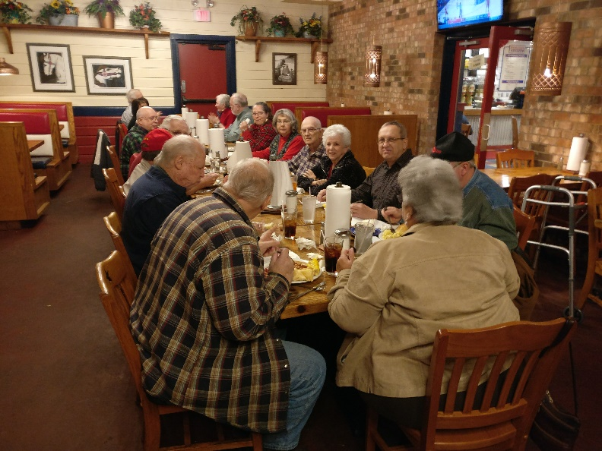

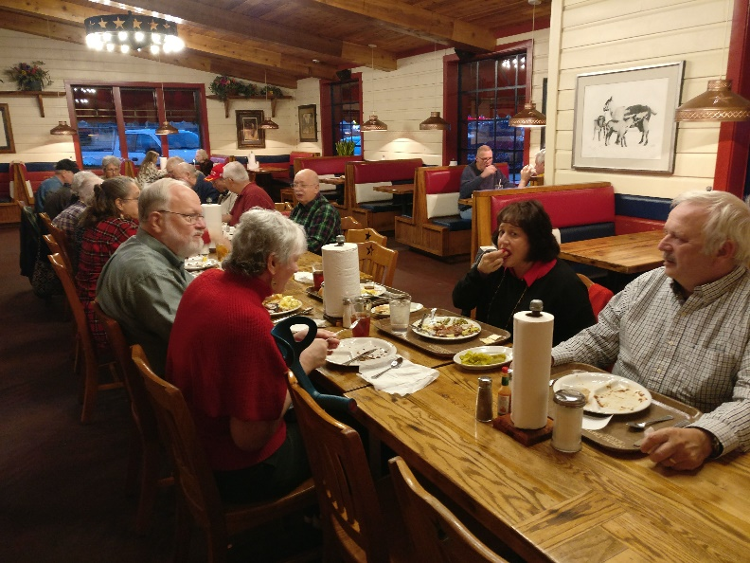

(*Continued on page 3*)

|  |  |  |  |  |  |  |  |  |  |
| --- | --- | --- | --- | --- | --- | --- | --- | --- | --- |
| **RCARC OFFICERS** | | | | | | | | | |
| **PRESIDENT** | | | | |  | **VICE-PRESIDENT** | | | |
| **VACANT** | | | |  |  | Gene Duprey | | K1GD | |
|  | | | |  |  | 319.270.8159 | |  | |
|  | | | | |  | [geneduprey2015@gmail.com](mailto:geneduprey2015@gmail.com) | | | |  |
|  | |  | | |  |  |  | | |
| **SECRETARY** | | | | |  | **TREASURER** | | | |
| Jim Brown | AF5MA | | | |  | Mike Montgomery | | | WD5TX |
| 972.495.2209 | | | | |  | 972.705.1498 | | |  |
| [jhksbrown@verizon.net](mailto:jhksbrown@verizon.net.) | | | | |  | [dmmontgo@rockwellcollins.com](file:///C:\AppData\Roaming\Microsoft\201401%20Signals\dmmontgo@rockwellcollins.com). | | | |
|  | |  | | |  |  |  | | |
| **ACTIVITIES CHAIRMAN** | | | | |  | **WEBSITE MANAGER** | | | |
| **VACANT** | | |  | |  | Mike Hollingsworth | | | W5QH |
|  | | |  | |  | 972.571.6060 | | |  |
|  | | | | |  | [w5qh@arrl.net](mailto:w5qh@arrl.net) | | |  |
|  | |  | | |  |  | | |  |
| **STATION TRUSTEE** | | | | |  | **NEWSLETTER EDITOR** | | | |
| Bob Kirby | | K3NT | | |  | Jim Skinner | WB0UNI | | |
| 319.360.0500 | |  | | |  | 214.535.5264 |  | | |
| [k3nt@arrl.net](mailto:k3nt@arrl.net) | | | | |  | [wb0uni@arrl.net](file:///C:\Downloads\JHB\AppData\Local\Documents%20and%20Settings\James%20Skinner\Briefcase\RCARC\SignalsArchives\201010%20Signals\wb0uni@arrl.net) | | | |
|  | | | | |  |  | | | |
| **MEMBERSHIP** | | | | |  | **W5ROK CLUB STATION** | | | |
| Joe Wolf | | | N5UIC | |  | 972.705.1349 | | | |
| 214.202.2757 | | |  | |  | 461-290 | | | |
| [n5uic@arrl.net](file:///C:\Downloads\JHB\AppData\Local\Documents%20and%20Settings\James%20Skinner\My%20Documents\Briefcase\RCARC\201111%20Signals\n5uic@arrl.net) | | | | |  |  | | | |

**VE SESSIONS**

**Dallas** tests are held on the fourth Saturday of each month at 1000 hrs. 13350 Floyd Rd. (Old Credit Union) Contact Bob West, WA8YCD 972.917.6362

**Irving** tests are held on the third Saturday of each month at 0900. Fifth and Main St. Contact Bill Revis, KF5BL 252-8015

**McKinney** VE test sessions are held at the Heard Museum the first Sunday of the month. The address is 1 Nature Place, McKinney TX. The time of the testing is 1430, ending no later than 1645. ***Note: no tests given on holiday weekends.***

**Garland** testing is held on the fourth Thursday of each month, excluding November, and begins at 1930 sharp. Location is Freeman Heights Baptist. Church, 1120 N Garland Ave, Garland (between W Walnut and Buckingham Rd). Enter via the north driveway. A HUGE parking lot is located behind the church. Both the parking lot and the Fellowship Hall are located on the east side of the church building, with big signs by the entrance door. Contact Janet Crenshaw, WB9ZPH at 972.302.9992.

**Plano** testing is on the third Saturday of each month, 1300 hrs at Williams High School, 1717 17th St. East Plano. Check Repeater 147.180+ for announcements.

**Richardson** The Richardson Wireless Klub (RWK) VE team hold license testing on the third Thursday of each month at St. Barnabas Presbyterian Church, 1220 West Beltline Rd. Testing begins at 1900 hrs in room 12. Enter through the Northern most door on the east side of the church building. For further information contact Dave Russell W2DMR, at 972.690.9894 or E-mail [warhog4 @tx,rr.com](mailto:warthog4@tx,rr.com).

**SIGNALS** is the monthly newsletter of the Rockwell Collins Amateur Radio Club, published by and for its members. The entire contents of this newsletter are copyright © 2016 by the Rockwell Collins Amateur Radio Club. Permission is hereby granted to any not-for-profit amateur radio publication to reprint any portion of this newsletter provided both the author and Rockwell Collins Amateur Radio Club are credited.

**President and VP Messages**

We are finally at years-end. This has been a crazy year for many of us, especially for me, and I am glad the year is ending, and the new year is soon to be here.

First off, there will be no December meeting, instead we are having a Christmas Dinner December 21, at Spring Creek Bar-B-Que, at 270 N Central Expy, Richardson. So lets all get together and have a great time with family and friends. The club will not be paying for the dinner this year.

I hope you are all well, and that Santa will grant your every Christmas wish.

Merry Christmas, and a Happy New Year to all.

See you at the meeting, 73's

Gene, K1GD

**Secretary's Report**

There is no Secretary’s Report for December 2016, since the meeting consisted of the annual RCARC Christmas party.

**2016 Christmas Party**

*(Continued from page 1)*

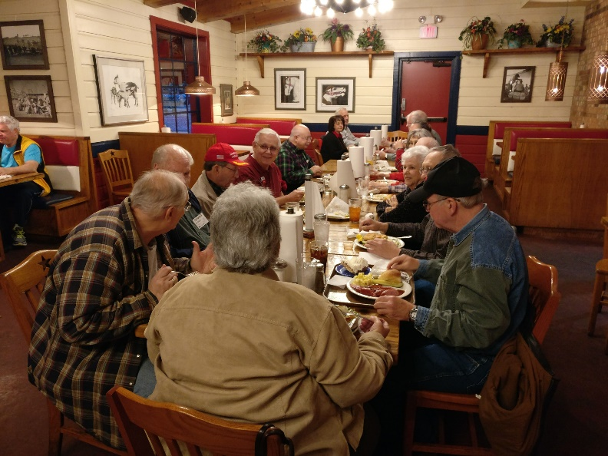

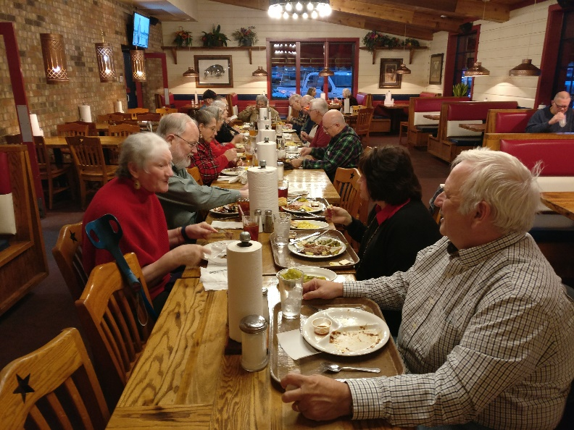

**A Cheap and Clean Source of Power**

Power supplies: we depend on them. The problem between radio operators and power supplies is what I like to call, the “money to magic ratio”. Dedicated amateur radio power supplies can seem disproportionally expensive compared to the magic our radios produce. Our requirements in the ham radio world are simple, a dependable and quiet source of power to get the job done. So why the expense? I don’t really know, but I can offer an alternative.

This article (and mostly from a linked article) will show you how to convert a Hewlett Packard 47amp 12 volt, server power supply (PS) for less than $30 total cost. The conversion can be done in under an hour. And I assure you, the job these HP server power supplies did in their last employment demanded quality.

So, let me introduce to you the PS we will be working with. It is a Hewlett Packard model DPS-600PB ESP135. It is rated at 575W, or 47A at 12V. This particular PS is called "redundant hot swappable” meaning the servers these power supplies’ operated ran 24/7. As needed, you could pull the PS out with the server still running and replace a PS. Picture the modern severs you see that fill entire rooms.

You can find this PS on Amazon or Ebay under the name "DPS-600PB ESP 135" and you will find the prices range from $19 shipped for a used unit, $40 for refurbished, and $60 for new. I suggest getting a used unit from Amazon, they are $19 shipped. That is what I have done, and my converted PS has been running great for over two years. Here is a direct link to the Amazon seller I purchased from.

<https://www.amazon.com/HP-Compaq-338022-001-Hot-Swap-DPS%20600PB/dp/B0045JSSWO/ref=sr_1_1?ie=UTF8&qid=1427030916&sr=8-1&keywords=DPS-600PB+ESP+135>

In the interest to save time and space, you will find a link below that is the most comprehensive and best described method to convert these power supplies. Also, I have included a reader’s digest version below the link in **BOLD,** just in case the link disappears or is unavailable.

<https://sites.google.com/site/tjinguytech/my-projects/HP47A>

**Use a 1k ohm pot between pins 3 and 9(+12 return sense) to increase voltage above 12v.**

**Use a 1k ohm pot between pins 5 and 9 to decrease voltage below 12v.**

**Or use a single 2k-10k pot with the outer legs tied to pins 3 and 5 and the center wiper to pin 9 for voltage adjustment above and below 12v.**

**Voltage is adjustable up to 13.8v on this supply. OVP starts at 13.82v.**

**If the PS shuts down at 13.8v with a load then just back down to a voltage that works for your particular situation.**

**Short pin 4 to ground to slow fan speed to a minimum or use pot for variable speed.**

**Once pin 4 is grounded, fan speed will be automatically adjusted based on load and ambient temperature.**

**Pin 4 is already internally connected to ground on the PS-3601-1C version of the ESP135 series.**

**Therefore, connect it to +12v to set fan speed to maximum.**

**Pin 11 is the +12v current share pin.**

***Short pins 6,8 and 10 together to power up*.**

**265Ω = 13.8v   
290Ω = 13.7v  
330Ω = 13.6v  
370Ω = 13.5v**

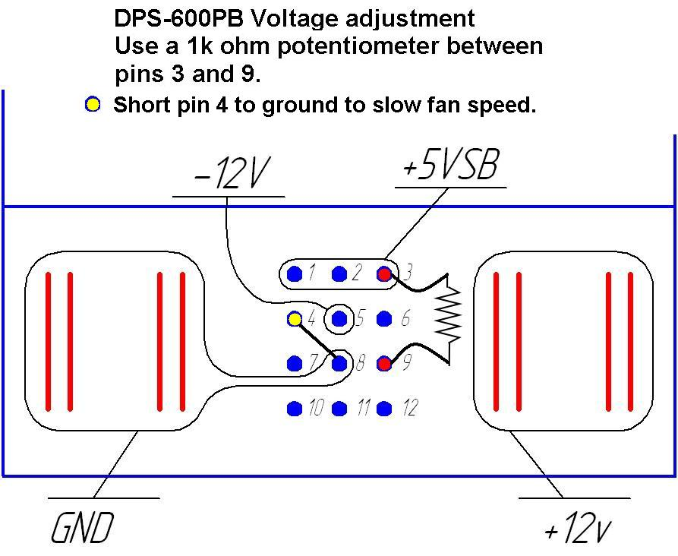

73 de RM Blake K5AGE

[k5age@fastmail.com](mailto:k5age@fastmail.com)

*(Contributed by Frank Krizan K5HS. Article reprinted with permission of the Nacogdoches Amateur Radio Club Newsletter, January 2017 and the author, R.M. Blake K5AGE)*

**Presentations for Monthly RCARC Meetings**

RCARC has an urgent need for presenters to present a short topic on Ham Radio at our monthly club meetings. 45-60 minute presentations may include, but are not limited to:

* Set-up, Building or Modifying Station Equipment (Antennas, Audio, Dummy Loads, Desks, Lights, ...)
* Operating a Radio Station (Listening & Transmission tips, Ham Logo decrypted, Popular Frequencies, ...)
* My Radio Broke (Possible Alternatives before using the Sledge Hammer, ...)
* Different types of Digital Operation (APRS, Packet, PSK 31-64, RTTY, ...)
* Software Defined Radios (Commercial, Kits, Remote, Internet, ...)
* Software used for Ham Radios (WSPR, PSK-31, ...)
* Emergency Radio Equipment (Go Kits, Batteries, Solar power, Easy-Up Antennas, ...)
* Ham Radio Activities (MARS, RACES, MARC, Contests, Satellites, Mobile, Portable, Remote, Field Day, SWL, ...)
* Radio Reference (On-line manuals, theory, how to books & Videos, ...
* Social Mingle (With light snacks? Ham and cheese crackers? ...)

If you would like more information on a particular topic, and would like someone to do a presentation on it, you may suggest it as a topic. Please email Bob Kirby K3NT, Jim Skinner WB0UNI or Gene Duprey K1GD to present a topic or to suggest a topic for presentation.

**Upcoming Events**

|  |  |
| --- | --- |
| **JANUARY** | |
| **21-23** | **JANUARY VHF** Objective: For amateurs in the US and Canada to work as many stations in as many 2 x 1 degree Maidenhead grid squares as possible using authorized frequencies above 50 MHz. Stations outside the US & Canada may only work stations in the US and Canada. Operation is from 1900 Saturday thru 0359 UTC Monday. Details at <http://www.arrl.org/january-vhf>. |
| **FEBRUARY** | |
| **13-17** | **School Club Roundup** Objective: To exchange QSO information with club stations that are part of an elementary, middle, high school or college. Non-school clubs and individuals are encouraged to participate. Sponsored by the ARRL, its Hudson Division Education Task Force and and the Long Island Mobile Amateur Radio Club (LIMARC) to foster contacts with and among school radio clubs. The event runs from 1300 UTC Monday through 2359 UTC Friday. A station may operate no more than 6 hours in a 24-hour period, and a maximum of 24 hours of the 107 hour event. Details at <http://www.arrl.org/school-club-roundup>. |
| **18-19** | **International DX—CW**  Objective: To encourage W/VE stations to expand knowledge of DX propagation on the HF and MF bands, improve operating skills, and improve station capability by creating a competition in which DX stations may only contact W/VE stations.  W/VE amateurs: Work as many DX stations in as many DXCC entities as possible on the 160, 80, 40, 20, 15, and 10 meter bands.  DX stations: Work as many W/VE stations in as many of the 48 contiguous states and provinces as possible.  The event runs 48 hours, from 0000 UTC Saturday through 2359 UTC Sunday. Details at <http://www.arrl.org/arrl-dx>. |
| **REGULAR ACTIVITIES** | |
| **Daily** | DFW Early Traffic Net (NTS) at 6:30pm 146.88 – PL 110.9Hz |
| **Daily** | DFW Late Traffic Net (NTS) at 10:30pm 146.72 – PL 110.9Hz |
| **Daily** | Texas CW Traffic Net at 7:00pm on 3541 KHz and at 10pm on 3541 KHz www.k6jt.com |
| **1st Wednesday** | Richardson Emergency Siren Test. At noon using the Richardson Wireless Klub (RWK) repeater at 147.120 MHz. |
| **2nd Wednesday** | ARES North Texas HF Net Every month—3860 KHz at 8:30 pm—9:30pm |

|  |  |
| --- | --- |
| Rockwell-Collins  **Amateur Radio Club**  **Mail Station 461-290**  **P.O. Box 833807**  **Richardson, TX 75083-3807** |  |
|  |  |
| **TO:** |  |

|  |  |
| --- | --- |
| RCARC_with_Pilliars___color | **CLUB STATIONS**  (972) 705-1349  **W5ROK REPEATER**  441.875 MHz +5 MHz Input  131.8 Hz PL - RX and TX  **W5ROK-1 PACKET BBS ROK Node**  145.05 MHz  **W5ROK-N1, W5ROK-N2 & W5ROK-N3 HSMM-MESHNET Nodes 2.4 GHz** |
| **Tuesday 24 January 2017**  **1700 Social 1730 Meeting**  **Methodist Richardson Medical Ctr**  **At Bush/Renner/Shiloh Intersection**  ***Conference Room A in Hospital Building*** |
| **NEXT SIGNALS INPUTS DEADLINE:**  **🡺🡺🡺 17 February 2017 🡸🡸🡸** | |